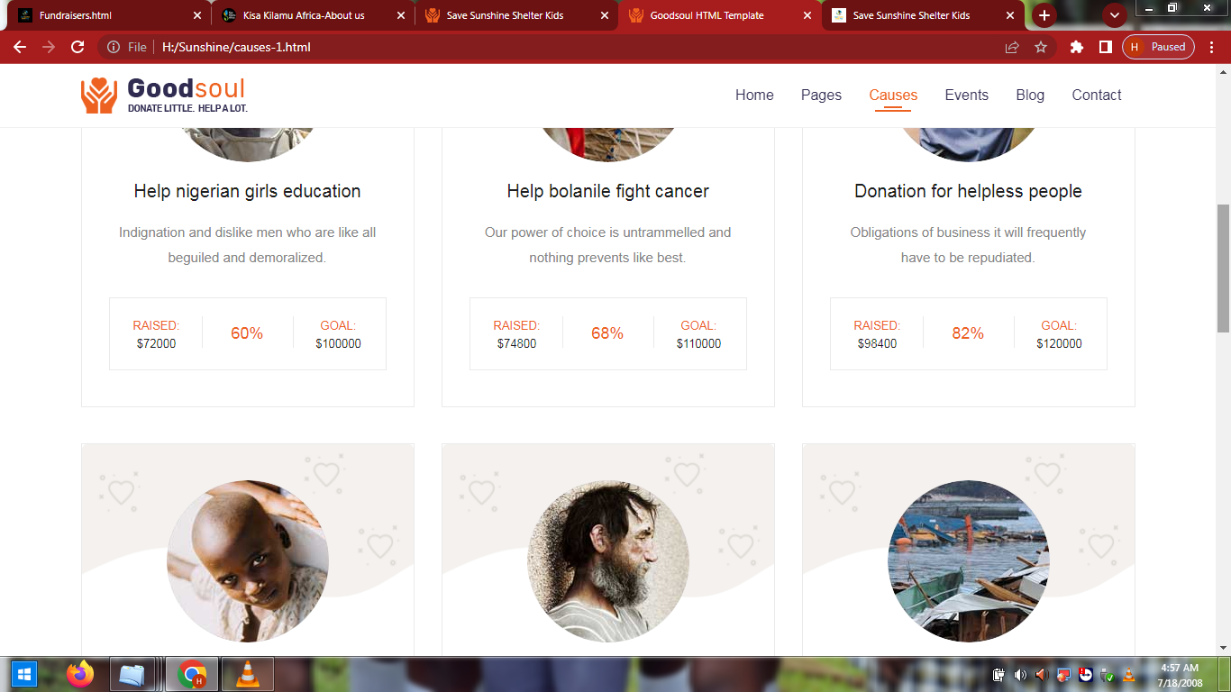
file:///H:/Sunshine/causes-1.html

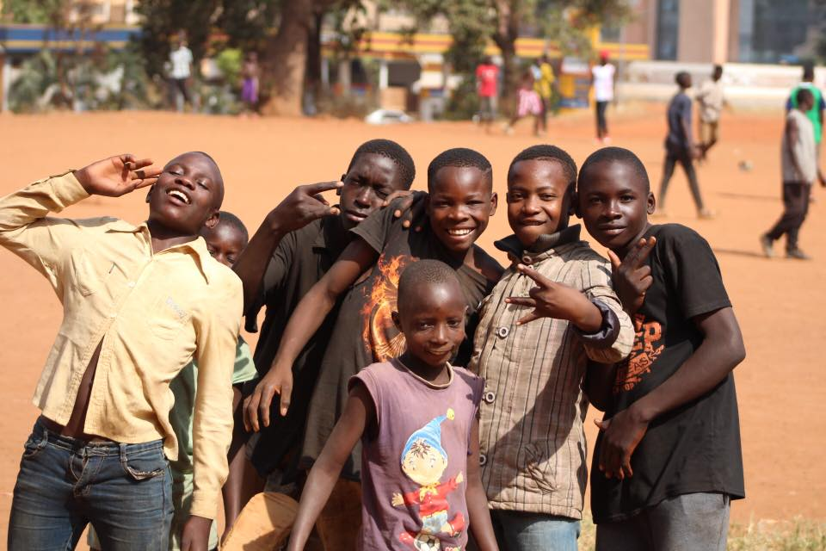
- STREET CHILDREN PROGRAMS (MONTHLY $1000)
The Street children outreach program remains at the core of our programs, it involves a number of activities and is the start of every step that is from rescuing a kid from the streets to the shelter. We carry out different activities under this program such as feeding, counseling, medical care, hygiene practices among others. A big number of street boy’s children show up every day for the program. It is a costly program that we do as it involves a number of activities. For a smooth process we need to have a center where kids drop in for the programs and they run from morning till evening. Street connected children tend to be derailed off a normal child's behavior as they are lured into the drug abuse vice. The abuse of drugs has been detrimental to morality and health of the children. They majorly abuse substances like aviation fuel, glue, marijuana among others. We would like to do more through this program and rescue as many children as possible. For this program to run smoothly every month it requires funding. We run this program from all day, Monday to Thursday. Much of our focus is on this program as it is the journey to understanding the various reasons as why many of these come to the streets every single day and find the prefect measures of helping them. A world where every child has a safe home.

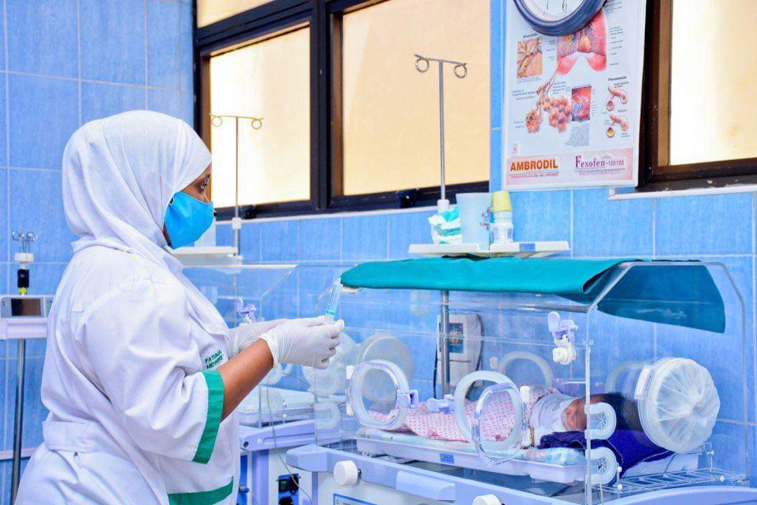
- HEALTH-MEDICAL CARE PROGRAMS (MONTHLY $1400)
Rescuing many children from the streets remains a priority, followed by ensuring and maintaining that their health is good. Healthcare is a vital need not only for the children and young teen mothers, the women on site but also all the communities that we serve. With an emphasis on prevention and care, we provide and support children, teen mothers, women and communities at large by ensuring that they have access to proper and quality care. Many of our children with chronic illnesses are well catered for and their monthly appointments are attended too. Our goal is to see all our children, women and the communities very safe, healthy and thus focusing on the greatest impact including malnutrition, HIV/AIDS, malaria and tuberculosis and also advocate by educating members of the local communities. Health care is equally the expensive as we have to tackle different health crises and illnesses that the children have and at times requiring surgeries or further treatments that are often expensive since they are to go on months. Many times with the teen mothers we acquire a lot of bills as there is need for intensive care for the mothers and their babies, many women in communities cannot afford some form of medication and thus we step in and provide medical care for many mothers plus children.

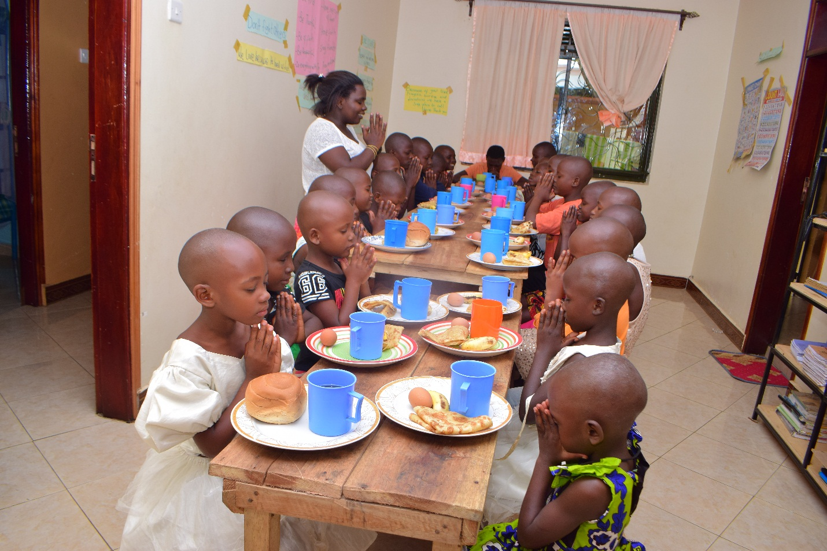
- REHABILITATION PROGRAMS (MONTHLY $1500)
Rehabilitation is a diverse one as it involves children from every part of Uganda and thus different ethnic groups that need to be brought together and acquire the same basic needs and emotional support. It is the most challenging program of the many that we run on a daily basis. The girls have their own shelter, away from the boys' and these are both havens emotional support and care. Most of our children share a similar story, that is coming from very poor families where their needs aren’t met and worsened by violence that many of them are forced to join the streets. While at the shelter, children are provided with food, love, education and other necessities of life, as well as programs to reintegrate them into society. The shelters main purpose is to temporarily house rescued children while rehabilitating and also provide a permanent home for those who have no resettlement options and thus making us their permanent guardians. This program is a process, a step by step work, as every child changes and transforms in his or her time and this demands for patience from the staff and the probation officers who we have to inform and contact regarding the children affairs. This program is costly as every day it has to run and needs have to be met on a daily basis. The needs of the children vary and thus every day we have to have money to meet the all needs. Children are joyous and gifts from God. Sheltering them is protection.

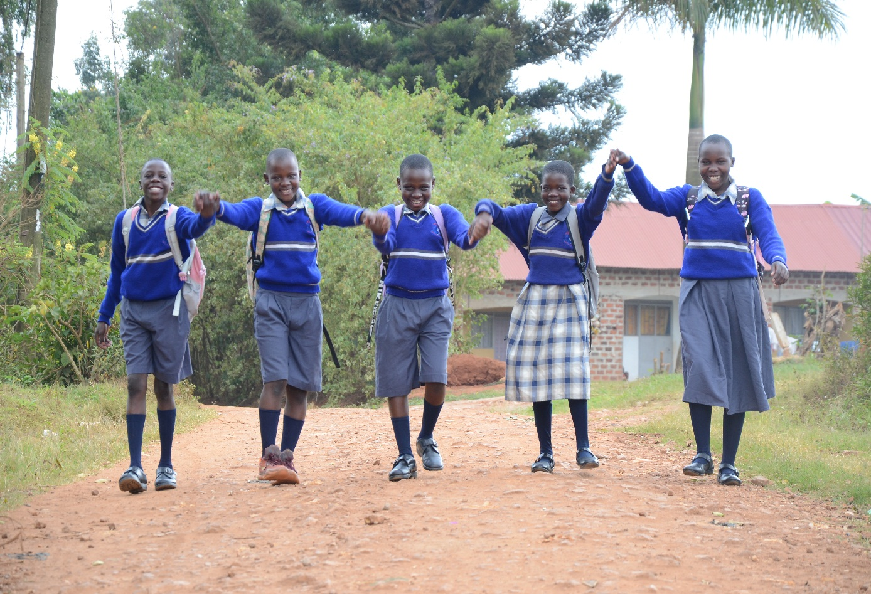
- EDUCATION PROGRAMS (TERMLY $6000)
Education empowers minds to make critical choices with the knowledge and information given to them. It is the key that unlocks one's potential as they are able to make informed decisions basing on the information at their disposal. Wisdom might go along way but without education the mile is complete. This explains why we are so passionate about education. For many of the children, once they are able to enroll into schools, we ensure they do. We have about 93 children that go to school. Those from the shelters, resettled homes and others from the communities. The education of the children does not only make us proud but also changes the whole community at large so join us to change communities together. Educate one and save a life. Many that would have ended up as thieves or lose their lives because of what the streets often turn them into get to become better people. $6000 covers all our children school fees per term/semester, needs and the scholastic materials, our children attend different schools and are in various class grades which requires different amounts of money to be paid. All our children attend private primary, secondary, vocational, institutional or universities, many of those who are in secondary attend boarding schools since it is a demand by various schools, those in primary and are in critical grades also attend boarding schools.

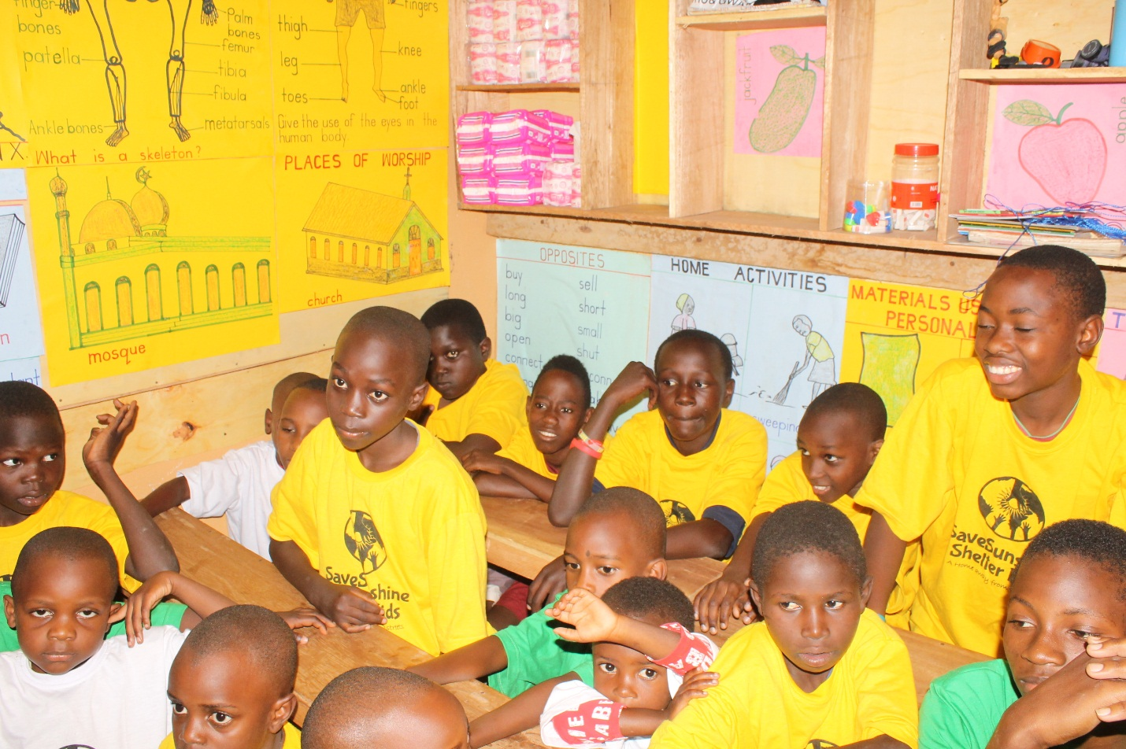
- DEBORAH'S LIBRARY (MONTHLY $800)
To many community children, the library is the safest place that keeps them from many dangerous activities and behaviors that would have led many to prison at such young ages. In reaching out too many children were able to reduce and put a limitation on the number of struggling children engaging into unhealthy addicted and theft behaviors. Many children attend our libraries whole week and others join us in the evening period. We offer what many children are unable to receive as they don't attend school and we give them a similar feeling like those children who go to school. We provide meals, reading materials etc. The $800 helps run the libraries throughout the month covering scholastic materials, clothes, bags, food and other basic needs that the children need to go back home with. Our libraries started as pop up libraries just reading with community kids every single day, however the number of children outgrew what we expected thus pushing us to start a single roomed library where kids go for studies just like normal children who attend school every day. The library aim was to reduce on the number of children from the dire communities that were joining the streets on a regular basis all the time and thus we aimed at relieving the pain and the burden many mothers/guardians were feeling watching their kids turn into undesirable members of society. We carry out the role of being the father and mother figures in the lives of many children that continue to attend our libraries every day. We provide all the needed necessities both for school and for home consumption to assist many mothers who are raising their children thus overwhelmed by the needs.

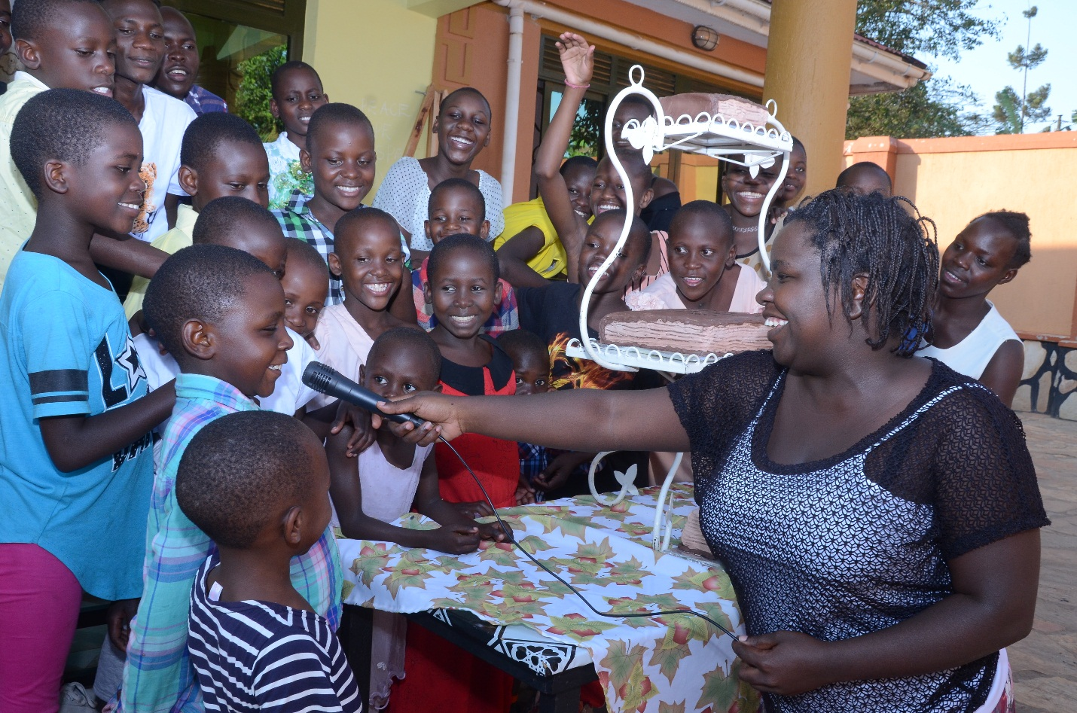
- ADVOCACY AND FACILITATION (MONTHLY $500)
To speak for and create awareness about the plight and challenges faced by the street children is a crucial step in reducing the influx of children on the streets. We try and sensitize the masses where these children come from and the communities they inhabit. It takes a village to raise a child and so we involve all those responsible plus calling them up to join us, see how best to reach out to the street children, design better measures of resettling and helping them from their homes. Join us in this long fight as we continue to advocate for many children, women and the many communities that we serve. Our program involves a number of activities that we are invited to participate in, speak on radios, televisions and other times participate in all arranged meetings about social changes and improvements. Our target is to ensure the responsible state bodies are aware of all the plight going on in the various communities that we serve so that whenever they set policies and guidelines for people in different districts to follow they are able to understand why certain reactions continue to raise in the various communities. We carry out local advocacy so that we can help each other that is involving the entire communities in the development of their children, women and the teens who are at a high risk of joining bad groups. We carry out campaigns that are aimed at promoting sanitation, teaching, health and re-organizational among leaders in order to solve social conflicts that keep communities in separation. This requires funds to run and ensure our work is done by our team members on ground on a daily. Join us to voice out the plight of the street kids.

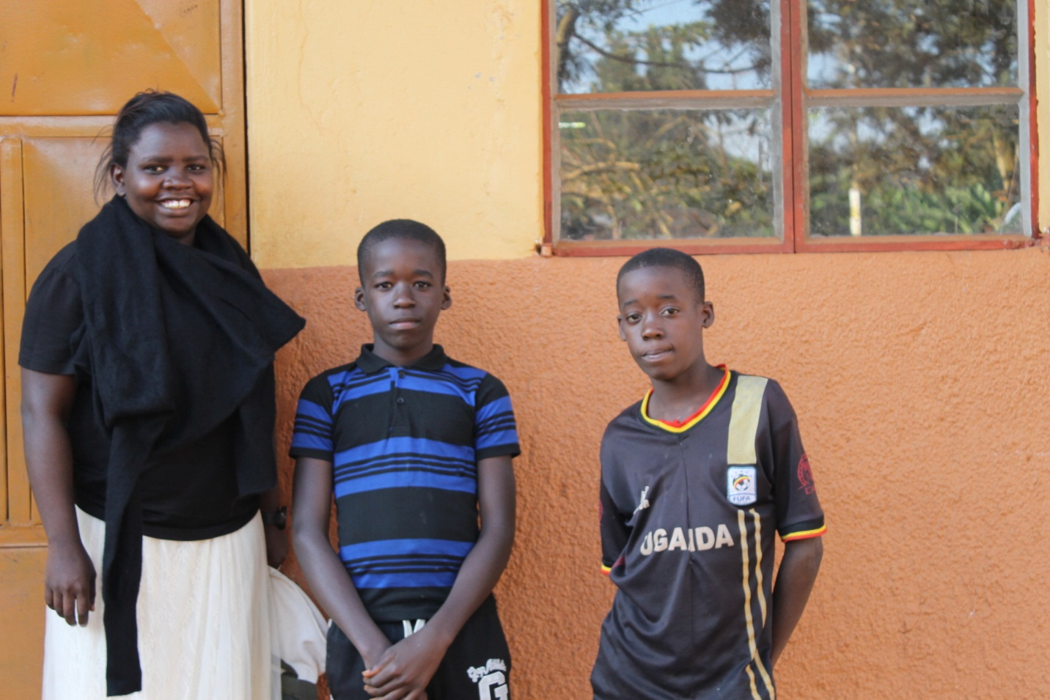
- RE-SETTLEMENT PROGRAMS (MONTHLY $500)
We believe that every child has the right to a family. Therefore, a big part of our work is to get to know the child’s story and work towards resettlement back to the family. Many children leave home due to harsh circumstances at home such as abuse, rejection or because of poverty and the vision of Kampala being the city of opportunities. When they finally get there, they realize street life isn’t as easy as they thought and they have no money to return. Re-settlement involves a number of activities: - Family tracing allows us to find and learn of the locations/Villages where many of the children come from and this takes much time as some parents and guardians are often in different places and we have to reach out to all of them in order to discover the truth behind the child's reason to join the streets. Follow- Ups We are always in contact with the families of the resettled children and extend assistance whenever they need it so as to help keep the children at home. Re-uniting and Final Resettlements Having all children well settled back into their families. Where Resettlement is possible, we re-unite the children with their families. With re-uniting comes some responsibility of us getting close to know the family and do surprise visits so as to ensure that kids are treated as we are told by their parents. This involves movement from one place to another and at times it can take two or more weeks because every relative is visited to be certain of where to put the child. We spend a lot of money during the Re-settlement process because it involves and getting all the legal documents from where we picked the kid and to where he/she has to be re-settled. Family unit is a priority for Us.

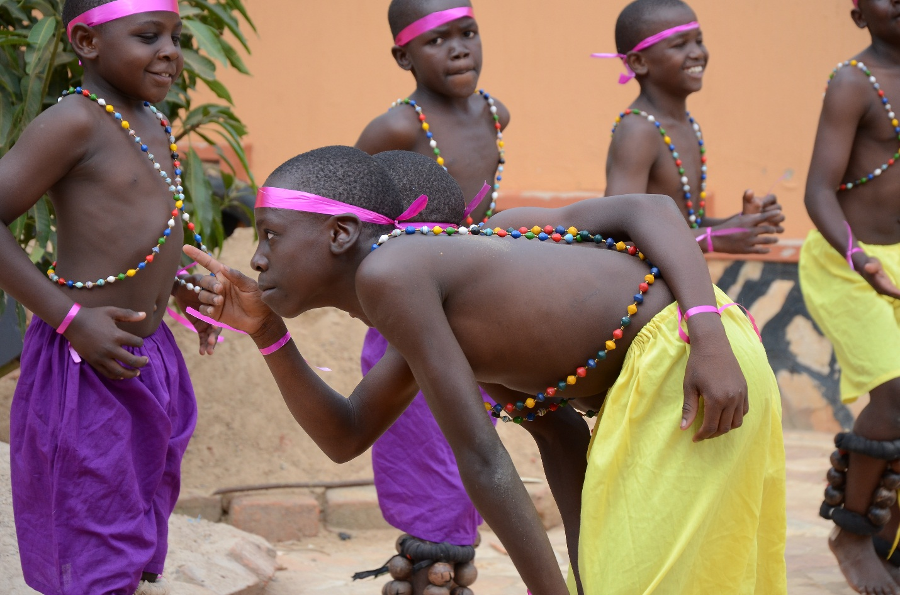

- TALENT GROWTH PROGRAMS (MONTHLY $4OO)
The quality and steadiness of one's life can be based on one's roots and how connected they are to them. We embrace the diversity in our cultures as we live in a multi-cultural society. The beauty of our languages, music, tales and dances is therapeutic. We invite children to learn about the dances and songs. It is so much fun when they sing and dance to the beats of their own roots. Through the competitions and performances, our children are able to share Christ’s love, grow in their faith, and continue learning to serve others as part of Save Sunshine Shelter for Kids’ mission to empower vulnerable children to become thriving leaders for Jesus Christ. With the two wins in the music competitions we surely have done great and witnessed wonderful results of change from the children. Music heals, provides therapy and allows them a chance to create and learn. Our musical instruments at the shelter have helped us so greatly. Through the Sunshine Dance Elite, our shelter children have done a wonderful joy in learning, practicing everyday especially during the holidays as it is the only time they are able to fully practice all day. Music unites all our children as they form, create and write all our Art together. This project requires money as some dances require us to hire teachers for it and also transportation in going to places where we can practice from as shelters are near people’s residency areas thus the noise from the drums is not tolerated by our neighbors. We are always in need of funds to purchase music instruments and transportation to place where we are to perform and show case our music talents. It is therapeutic to all children at the shelters and programs.

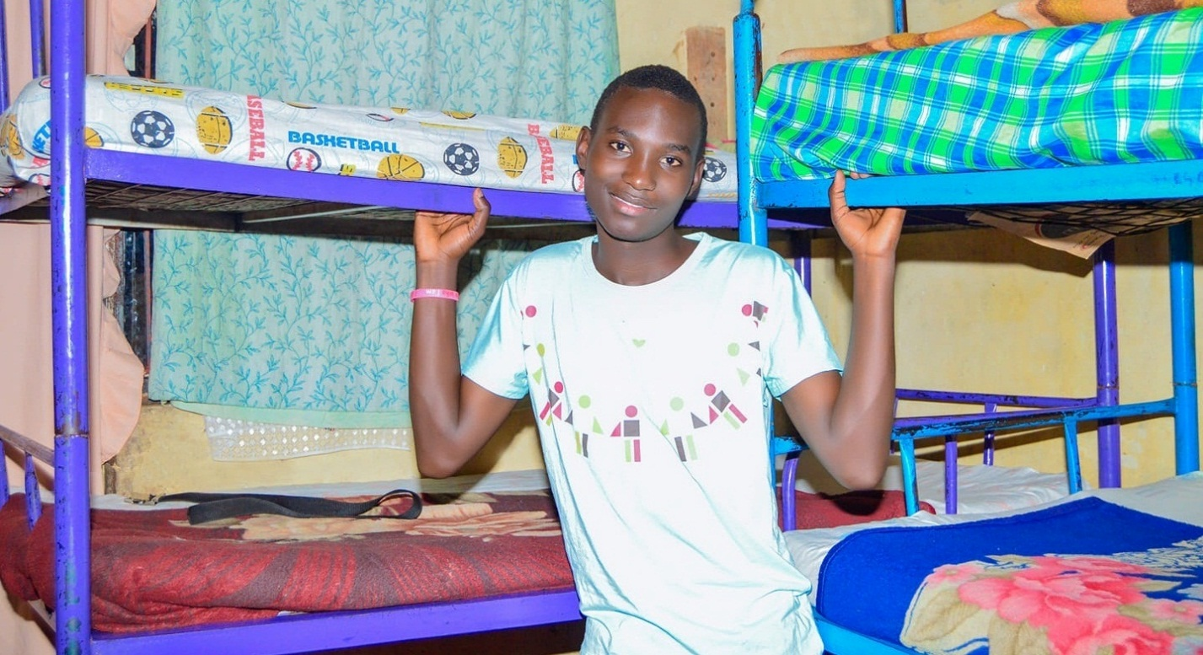
- HIDE OUT CENTRE PROGRAMS (MONTHLY $600)
These centers emerged out of the emergencies and turmoil of the COVID-19 crisis 2020. We created these centers during the COVID-19 pandemic crisis as many street children were lost, confused, unattended to and this is because many programs by different organizations closed and could hardly sustain their programs of the day and sheltering. After rescuing the children from the streets, the hide out centers are the first paths they go through so as to identify what their challenges are, where they are from and collect information on how best to help them start the transitional process. We have one hide out center currently where children who are rescued from the streets immediately go to and be counseled, family tracing, drug sensitization occurs at the hide out centers. It is always fully occupied and works as the emergency center for kids who come in with critical conditions. This center operates on funds and requires a lot as children come in every single day looking for a safe home and assistance.

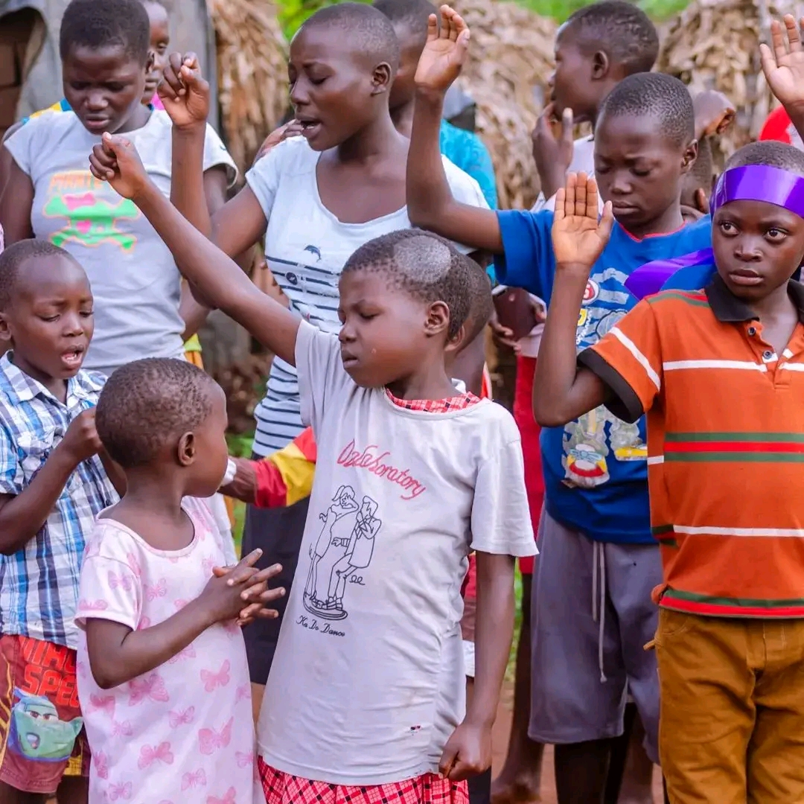

- THE FAR PROJECT PROGRAMS (MONTHLY $500)
This program encompasses four major programs that we run outside the city. Each has a major aim and a specific responsibility and this was born out of the COVID-19 crisis as many women and their children were suffering largely. The four programs include: - she rears project, let them talk, write and learn, Farming and our land. We initiated this program to combat the problem of children running away from rural villages to the streets in search of a better life and also to give chance to many women who are coming to the city with hope of finding easy jobs and better living conditions which cost many, their lives and the little that they owned. We have a small piece of land that allows us help the women through the production that we grow and plant together. We often take on all the medical bills mostly. We are focused on restoring and empowering the parents so that they can easily cater for themselves and their children. It requires funds in order to run so that we can provide for the children and also get the parents back on their feet. We involve the children in all activities.

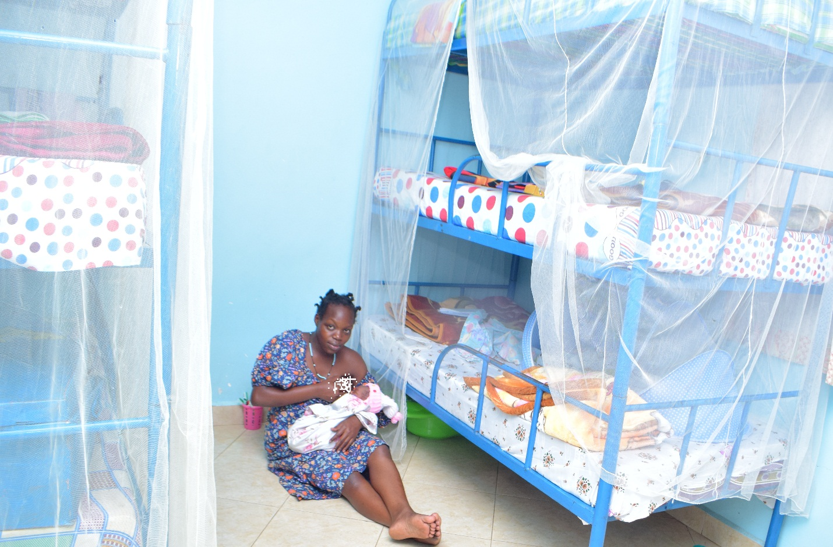
- CODY RESCUE CENTRE FOR TEEN MOTHERS (MONTHLY $600)
In Uganda, Teen mothers in general are dying at an alarming and increasing rate. According to Research data, Uganda's Maternal Mortality Rate (MMR) has consistently been one of the world's highest. Having a baby should be a time of great joy and hope but always a challenge. Girls who find themselves in the slums or grow up in the slums are exploited sexually from as young as 12 years old. From the age of 12 years they become a potential target. Many are “lured” to a life of prostitution with the "reward” that they may be able to have somewhere to sleep and occasionally get something to eat. There can be as many as 8 girls in 1 room and often used for sex in any way the client sees fit and have no freedom of choice. They share the rent for the room and assist each other in any way they can. Girls as young as 13 and 14 may find themselves pregnant and needing to not only provide for themselves, but for their babies as well. We are endeavoring to establish both a corrective and preventative way forward.

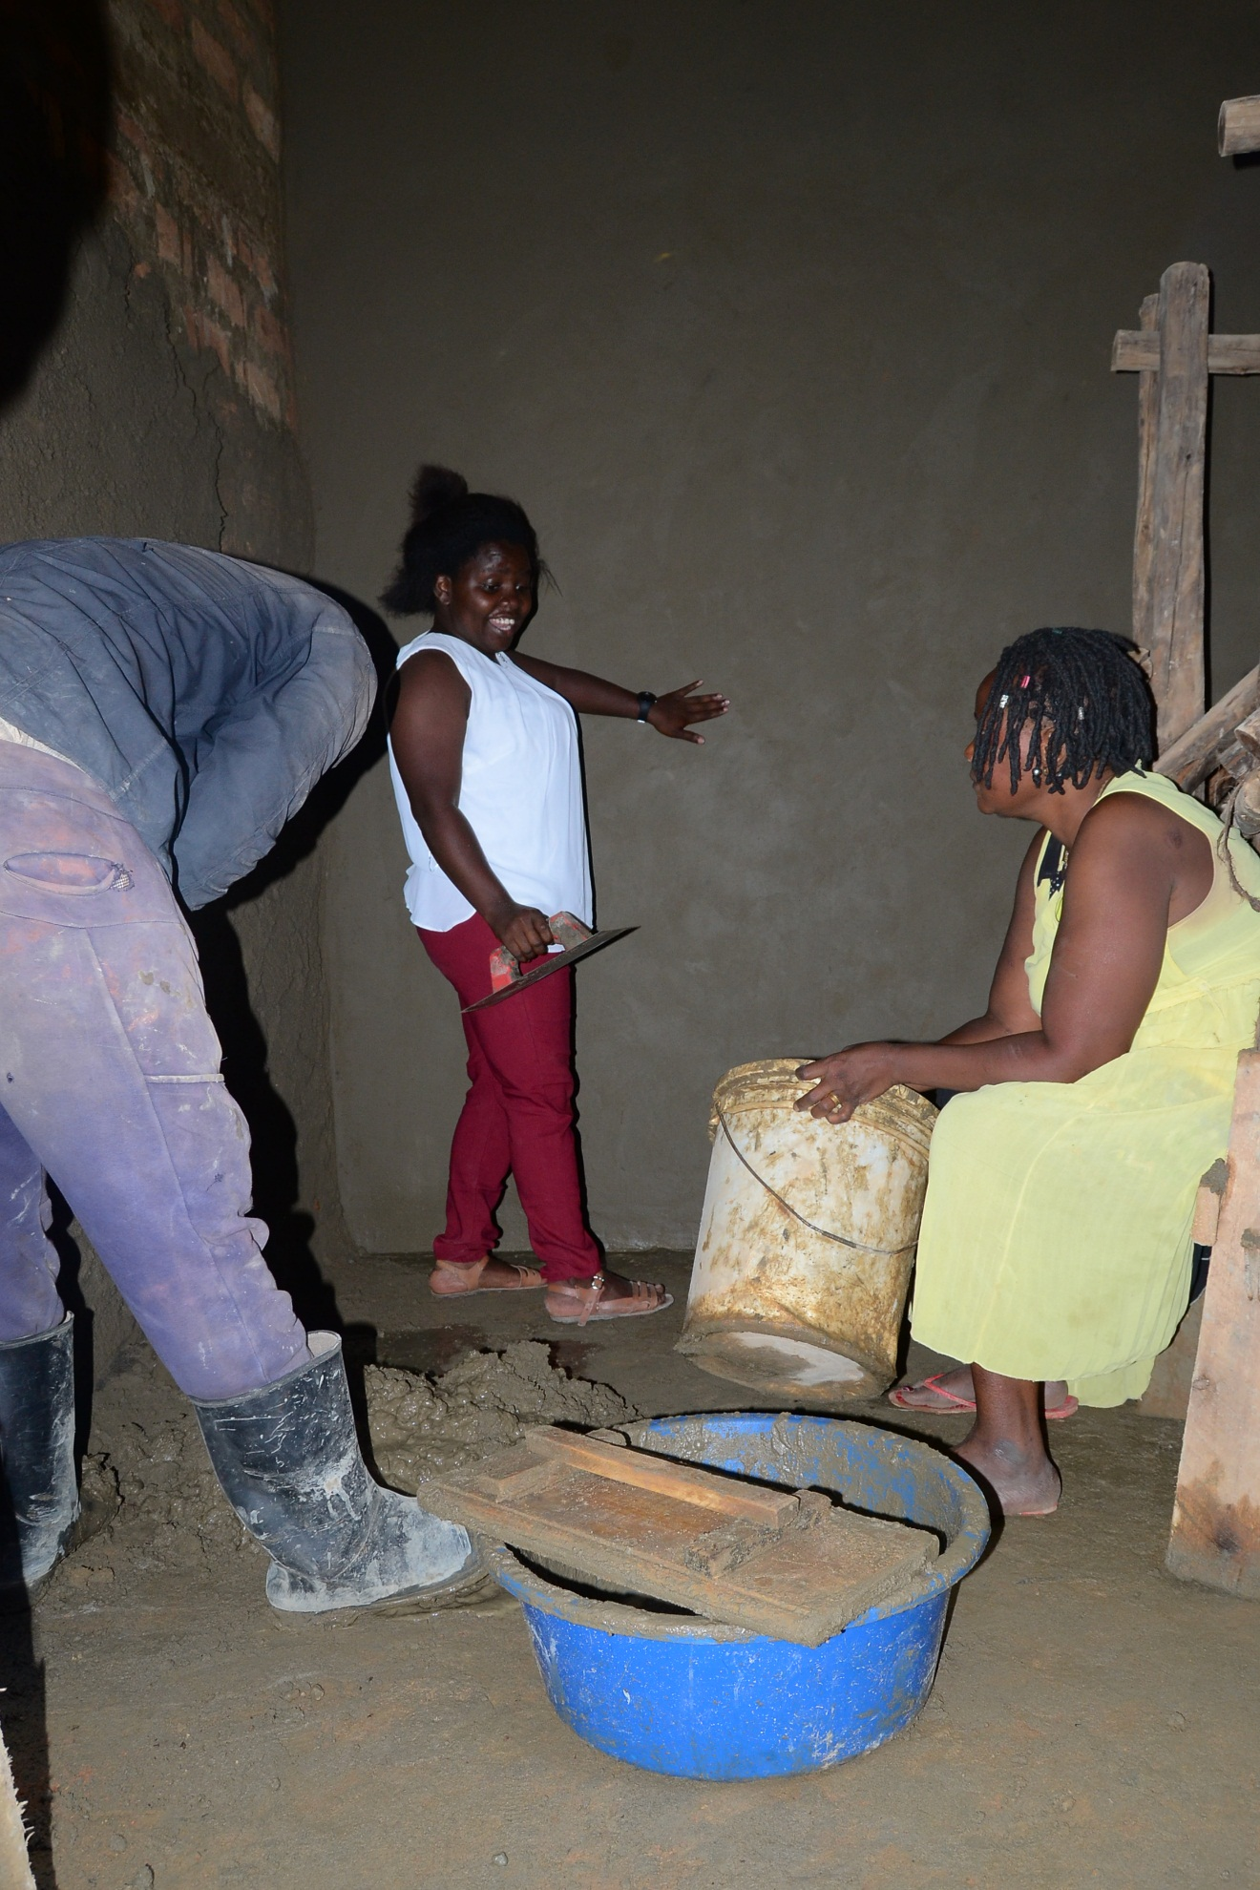
- BUILDING AND RESTORING HOMES PROGRAMS (A HOUSE $4000)
In countries like Uganda, single mothers often struggle to care for their children and at the same time meeting all their needs. We have equipped them and gave many families animals to rear so as to help them raise their children who are often orphaned and abused. By giving a family a home, you help care for the children who have spent much of their lives living in flooding and cardboard houses and bringing joy to a mother's heart with a place that she and her children can feel safe and secure. Most of the women are in dire situations, can hardly make it through the day to provide for their families and thus makes it hard for them to neither build nor renovate their houses, many of their houses are always leaking, demolished on certain sides, not strong for cold and rainy seasons, small and unfit for the children’s health. keeping families together is all we aim at. Consider renovating or building a home for family that is in a need of "A safe home to raise the children and the security they need." Come build.

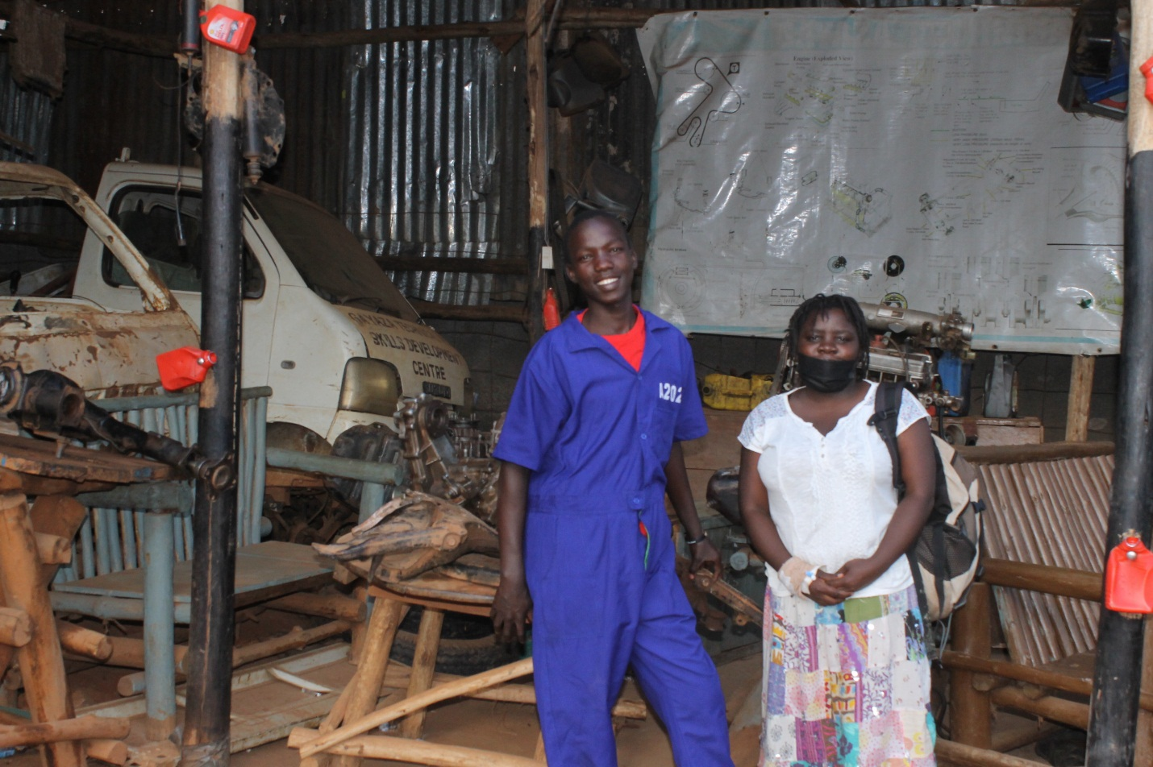

- VOCATIONAL TRAINING (YEARLY $1000)
A skill learnt is a job at hand. For those children who have past the age of enrolling in school due to their age and fear of the stigmatization, we take them for vocational & skills training where they learn various skills that will help them earn a living in future. Unemployment being a global problem, the skills they learn will help them to thrive though this competitive world and also to be job creators. Because many of the street children stay longer on the streets they tend to be unfit for normal schooling like other children and thus the only solution often is to enroll them in vocational training schools where they are able to acquire various skills in different fields such as welding, mechanical repair (motor- vehicle). It is an expensive program and it requires a lot of materials for the students as each course has its own requirements. We want to see children get skills and be independent.

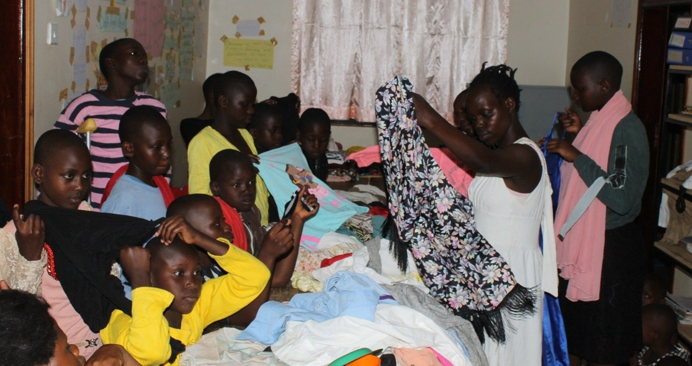
- CLOTHING AND SANITARY WARE PROGRAMS (QUARTERLY $500)
Under this project, we are able to deliver clothes such as jackets, warm sweaters to the street kids who attend our programs. We have given clothes to many street kids and those in the communities during night outreaches and sandals to street children who often have to suffer walking barefooted which poses harm to them. The lack of sanitary pads is one of the girl’s strongest barrier against many of the things she wants to achieve such as education, engagement among others. It continues to harden the lives of many girls in the different localities. In order to build, cherish our girls we ensure that they have what it takes them to be strong and stand firm in school and in communities where often stereotypes continue to be a disadvantage to them. Join us to provide clothes and pads for those in need for the need is still huge. We want them enclosed and protected.

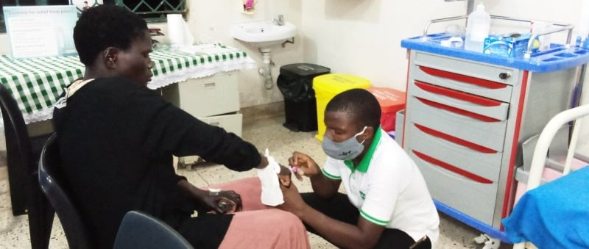

- HIV-AIDS COUNSELLING AND SENSITIZATION (QUARTERLY $400)
It does not make people dangerous to know, so you can shake their hands and give them a hug: Heaven knows they need it. We continue to witness a number of young people, mothers and community die due to the HIV/AIDS virus. We run awareness and invite doctors to offer advice, blood testing and counselling so as to help infected parents/community to acquire help. We call on movements and organize health talks with children, mothers, families and communities at large. HIV/AIDS has devastated much of Uganda's population and a bigger number of people are unaware more so less interested about this health crisis which is creating millions of orphans, not only in Uganda but around the World. HIV/AIDS is the major cause for many children joining the streets every day, the loss of their parents, the inadequacy in attaining their basic needs continues to be the push factor for joining streets.

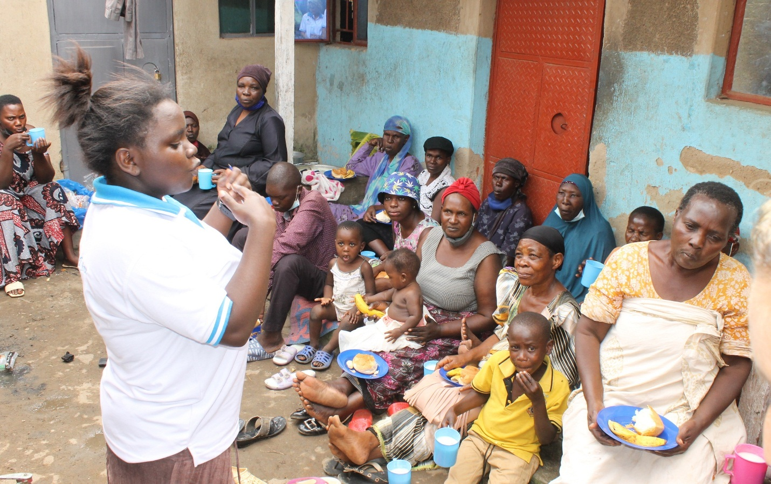
- STA WING FOR WOMEN PROGRAMS ($800)
We have witnessed tremendous challenges and devastation in the communities we serve and to help curb these injustices (Violence, Abuse, poverty, illiteracy, HIV/AIDS, mental health, Rape, mob justice, homeless among others) we empower communities more especially women who seem to be marginalized to protect our youth and to encourage healthy behavior free from being drunk and other forms of alcohol abuse. This wing provides shelter to different women who attain our programs and those we need medication and food supplies. Many women have refuge in the wing each time they are running away from violence and also take their medication. Various programs are done under this all aimed at helping, developing the women at large, ensuring that we restore dignity and rebuild up the broken families by empowering "Women"

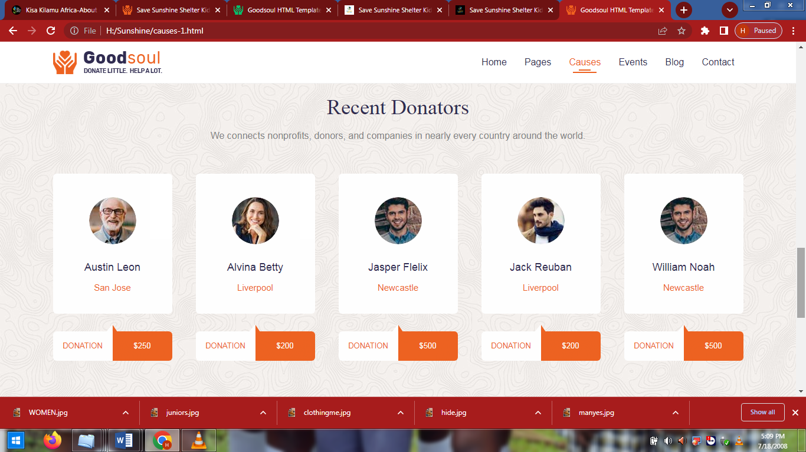

Our Donors
Your help impacts and transforms many lives.
Where there is face image of donors put flags of their countries
Mrs. Alice (2014 - 2015)
United Kingdom
$3000

Mr. Maurice (2014)
Ireland
$200

Mrs. Emma (2016)
United Kingdom
$400

Mrs. Lisa (2017)
USA
$200

Mr. Ruth (2019 - 2020)
Canada

